|  |
| --- |
|  |
| School Management System |
| Synopsis |
|  |
| **Susmita Podder( 105140695 )** |
|  |

|  |
| --- |
|  |

Table of Contents

1. Introduction 2

1.1 Background 2

1.2 Objective 2

1.3 Purpose and Scope 3

1.3.1 Purpose 3

1.3.2 Scope 4

2. SURVEY OF TECHNOLOGY 4

Programming FRAMEWORK (.NET 4) 5

Programming Language (C#) 5

Database - MySQL 5

3. REQUIREMENTS AND ANALYSIS 6

3.1 Problem Definition 6

3.1.1 Existing System 6

3.1.2 Documents maintained 7

3.1.3 Work To Be Done 8

3.2 Requirements Specification 8

3.2.1 Functional Requirements 8

3.2.2 Non-Functional Requirements 11

3.3 Planning and Scheduling 11

Gantt chart 11

Tracking Gantt 12

Pert chart (Network Diagram) 12

3.4 Hardware and Software Requirements 13

3.4.1 Hardware Requirements 13

3.4.2 Software Requirements 13

3.5 PRELIMINARY PRODUCT DESCRIPTION 14

3.6 CONCEPTUAL MODELS 15

3.6.1 E-R Diagram 15

3.6.2 Context Diagram 18

3.6.3 Data Flow Diagram 18

4. REFERENCES 19

# Introduction

## Background

The population of our country is increasing rapidly, but the resources for providing proper education to the children are limited. So we need to utilize our existing school management processes properly with the help of digital technologies.

Most of the schools are managed by a single authority like head master or a group of people like governing body. But in this fast paced world people tend to switch jobs. If the key people leave the school then the quality of education and school management deteriorates. There are so many dependencies on the school management personnel. We can eradicate this dependency by deploying a computerized solution for managing school.

Nowadays both of the parents are employed for most kids and they don’t have enough time to interact with teachers frequently. We need a computerized system to manage interaction between parents and teachers.

We will implement a school management system to address these issues and bring up an efficient system to manage activities of a school using single software.

## Objective

School Management System is versatile and complete end-to-end school management software .School Management System is used to enhance the administrative efficiency of educational institutions. It is an interactive platform for all entities viz. Students, Teachers, Management, Parents. It is a simple yet powerful one point integrated platform that connects all the departments of an institution namely office, fee counter, library, hostel, stores, academics, activity center and so on.

## Purpose and Scope

### Purpose

Managing a School manually is a challenging task. There are thousands of students and almost double the number of parents. There are a number of teacher and staff members in a school. Managing data of all stakeholders manually can be a complex and time confusing task. To establish a good reputation of the school we need all information regarding students, their parents, teachers and staff on our tips. And this is possible only by using a School Management Software.

The main purpose of School Management System is to help schools manage various operations including student data, administrative, and fundamental operations.

The main advantages of School Management System over managing manually the whole Schooling system are given below:

1. School management systems make the information flow quicker and more accessible.
2. They provide teachers with useful tools to decrease the daily routine of simple tasks which could be automated.
3. The management of the software is more centralized and easier to keep updated.
4. By implementing software to manage daily school needs teachers and administrators can save time and have a good overview of resources.
5. School systems are needed for all parties involved in education – parents, children, teachers and schools. Parent interest usually is to have a better and quicker way to communicate with teachers of their children or the school administration. They get more involved as they can get up-to-date information about the school events, grades, children school attendance, homework etc.
6. Teachers get automated reports and average grades in the end of a semester.
7. Children have a list of the home tasks, digital learning materials.
8. It saves a lot of time for the people involved in analyzing of the school performance automatically.

### Scope

Currently this software is aimed for a single school management. It can be extended to support networked multiple school and have a centralized database and to serve wider range of students of different branches of same School around the country.

We have developed this for Desktop Computers running on Windows Operating System. It can be enhanced to support UNIX / Linux, MAC OSX Operating systems.

Our software will not be integrated with Mobile Application right now. But in future we can easily extend to support that.

# SURVEY OF TECHNOLOGY

This software will follow Object Oriented Programming Paradigm and use below mentionedareas.

**Front End/ GUI Tools**: Visual Studio 2010, .NET 4.0, C#

**Backend:** MySQL

**Networking Technologies:** TCP/IP

**Operating Systems:** Windows XP, Windows 7

**Application Type:** ERP application, Database Management System.

## Programming FRAMEWORK (.NET 4)

The .NET 4 Framework is Microsoft's platform for building applications that have visually stunning user experiences, seamless and secure communication, and the ability to model a range of business processes. The .Net Framework consists of:

**Common Language Runtime** – provides an abstraction layer over the operating system

**Base Class Libraries** – pre-built code for common low-level programming tasks

**Development frameworks & technologies** – reusable, customizable solutions for larger programming tasks.

The framework's Base Class provides user interface, data access, database connectivity, cryptography, web application development, numeric algorithms, and network communications. The class library is used by programmers, who combine it with their own code to produce applications.

## Programming Language (C#)

C# is a type-safe, object-oriented language that is simple yet powerful, allowing programmers to build a breadth of applications.

C# is a multi-paradigm programming language encompassing imperative, declarative, functional, generic, object-oriented (class-based), and component-oriented programming disciplines.

It was developed by Microsoft within the .NET initiative and later approved as a standard by Ecma (ECMA-334) and ISO (ISO/IEC 23270). C# is one of the programming languages designed for the Common Language Infrastructure.

C# is intended to be a simple, modern, general-purpose, object-oriented programming language.

## Database - MySQL

MySQL is the world's most popular open source database software, with over 100 million copies of its software downloaded or distributed throughout its history.

The MySQL Community Edition includes:

* Pluggable Storage Engine Architecture
* **Multiple Storage Engines**: InnoDB , MyISAM, NDB (MySQL Cluster),Memory ,Merge , Archive, CSV
* MySQL Replication to improve application performance and scalability
* MySQL Partitioning to improve performance and management of large database applications
* Stored Procedures to improve developer productivity

School Management System

# REQUIREMENTS AND ANALYSIS

## Problem Definition

### Existing System

The existing system is traditional paper books and ledger system where several records are stored and to track other details about the student and teacher. The flow diagram of how a student takes admission in Schools is shown below:

|  |  |  |  |  |  |  |  |
| --- | --- | --- | --- | --- | --- | --- | --- |
| |  | | --- | | Student must take a registration form from the school with a small amount as a cost of registration form. |  |  | | --- | | Fill up the form by the student and submit to the School. |  |  | | --- | | According to the submitted registration form, an interview will be arranged. |  |  | | --- | | If the student passed the interview then he/she can take admission in the school with a admission fees. |  |  | | --- | | He/ She will get study materials from the School. |  |  | | --- | | He / She must pay the overall Tuition fees over the Year. |  |  | | --- | | He / She can join the Class. | |

The flow diagram of how a Student is promoted to next class according to his / her Results is shown below:

|  |  |  |  |  |  |  |  |
| --- | --- | --- | --- | --- | --- | --- | --- |
| |  | | --- | | Checks the attendance of the Student whether he/she has 75% attendance. |  |  | | --- | | If he/she has , an admit card will be issued |  |  | | --- | | He / She can give the exam. |  |  | | --- | | Records are stored in the system. |  |  | | --- | | Checks the getting numbers in each subject whether it is more than 40%. |  |  | | --- | | If yes, then He / She will be promoted to the next class. |  |  | | --- | | Mark sheet given. | |

### Documents maintained

**Application Register:** Application Number, Name, Address with Contact Number, Load, Initial

Deposit Amount, Application Received Date, Quotation Amount, Quotation Sent Date, Amount

Received On, Service Connection Number.

* **Service Connection Register:** Service Connection Number, Application Number, Name,Address with Contact Number, Quotation Amount, Amount Received Date, Work Assigned To (Contractor), Work Completed on Date.
* **Meter Movement Register:** Service Connection Number, Name Address with Contact Number,Meter Number, Seal Number, Meter Issue Date, Work Assigned To (Staff), Date of Connection
* **Estimation Sheet per Application:** contains input Application Number, name, Address with Contact Number, Wire Length Required, Angle Type and calculates Weight of Angle, andQuotation amount

### Work To Be Done

We will incorporate the above mentioned workflow of anSchool Management System in an automatic computerized way.

## Requirements Specification

### Functional Requirements

Function 1: View and Enter new Student and Employee information

The details of new student and employee admitted are kept. Details can be viewed later on whenever required.

Function 2: View and Enter new timetable information

Employee number and department number must be unique, and when entering timetable of any employee or teacher both values must be valid references. Week range must be between 1to 52.

Function 3: Security

The network operating system in the department will be used to enforce security. So that only the high level members of the School and Network manager will have access to the system.Another security level should also be incorporated to make the system more secure.

Function 4: Changing Password and Username

Password and Username can be changed according to the Employee requirement whenever they want to change for better security of the System.

Function 5: Mail Notification

If holiday is declared suddenly, all students, teachers and employees are informed by sending them a mail.

Function 6: Skill details

It is common for Employees who are teacher, to frequently attain skills in a number of various disciplines. Thus it will be effective to have a system where we can add new skills to the database as well as displaying the skills possessed by an employee.

Function 7: Exam Grade Details

Exam details like exam datasheet preparation, how many students will appear in specific exam etc. Depends on those things, Grade card can be generated for individual students. Exam administrators would need to be able to view, update, delete, print and add grade details.

Function 8 : Fees Details

Fees details of all Students are kept and they are reminded after every 4 days after last date. Late Fee is also charged after last date.

### Non-Functional Requirements

* **Efficiency**:

It will be efficient as it reduces manual labor and searching.

* **Backup**:

The employees will take regular print out of daily reports and take back up. Digital back up can be taken in a regular interval.

* **Documentation**:

ESCMS will have user manual and help documents.

* **Maintainability**:

It is designed such a way that it can be maintained with minimal effort.

* **Performance**:

The response time of ESCMS will be very fast. So it will be efficient enough to cater the customer.

* **Privacy**:

The data will be encrypted and the user data will not be shared with third party.

* **Security**:

ESCMS will use secure connection and enhanced security measures to protect data.

* **Usability**:

It will be very user friendly and usable by any person with minimal computer knowledge.

## Planning and Scheduling

### Gantt chart

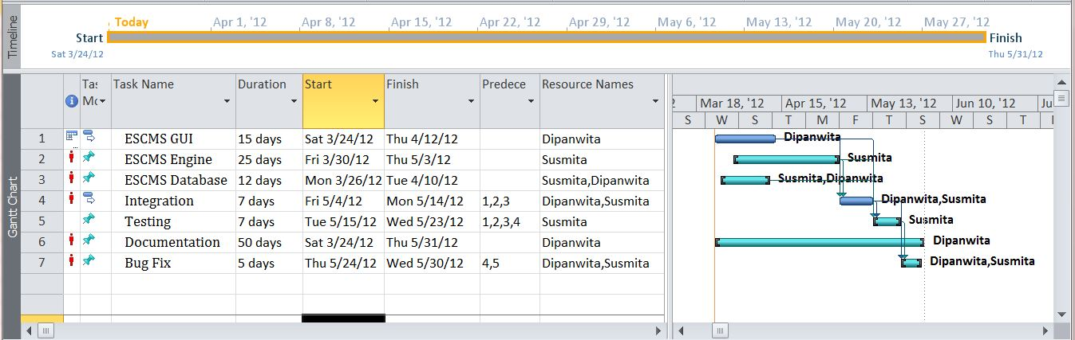

### Tracking Gantt

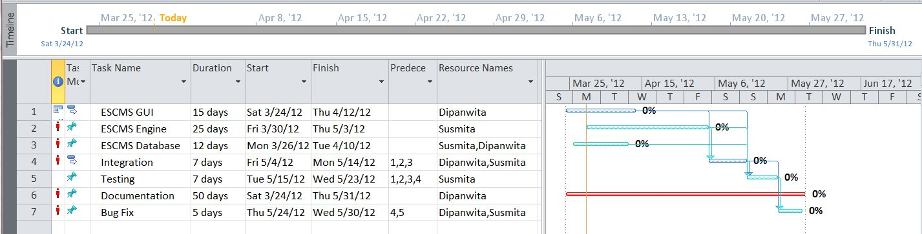

### Pert chart (Network Diagram)

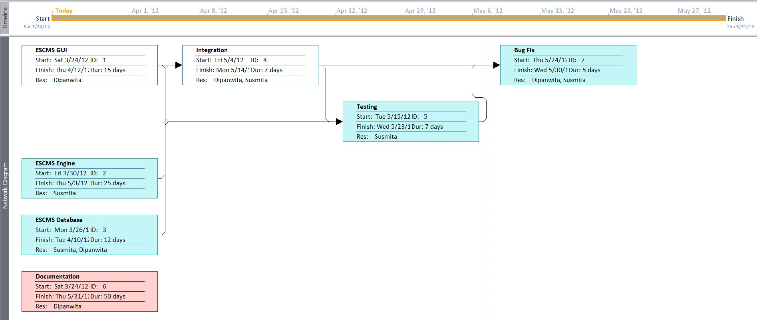

## Hardware and Software Requirements

### Hardware Requirements

* Computer that has a 1.6GHz or faster processor
* 1 GB (32 Bit) or 2 GB (64 Bit) RAM
* 10 MB of available hard disk space
* DVD-ROM Drive / USB Port

### Software Requirements

* Windows XP (x86) with Service Pack 3 / Windows Vista (x86 & x64) with
* Service Pack 2 / Windows 7 (x86 & x64)
* Microsoft .NET 4.0

## PRELIMINARY PRODUCT DESCRIPTION

School Management System will upgrade the existing system, so it needs to havegood support for existing system as well. It will collect the data from customers & employees andpopulate records which will match existing paper book registers. So that employees can take printout and maintain similar records. School Management System consists of threemain modules:

* ESCMS GUI
* ESCMS Engine
* ESCMS Database

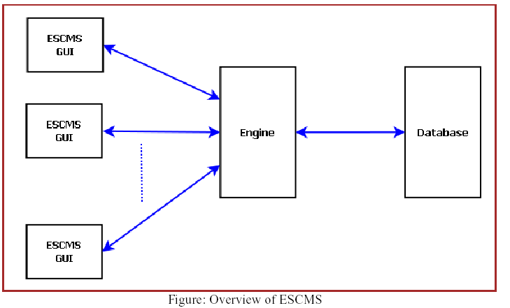

## CONCEPTUAL MODELS

### E-R Diagram

We will design a RDBMS for File Management System. The entities and their attributes are listed below. Attributes in Bold letter is the unique key.

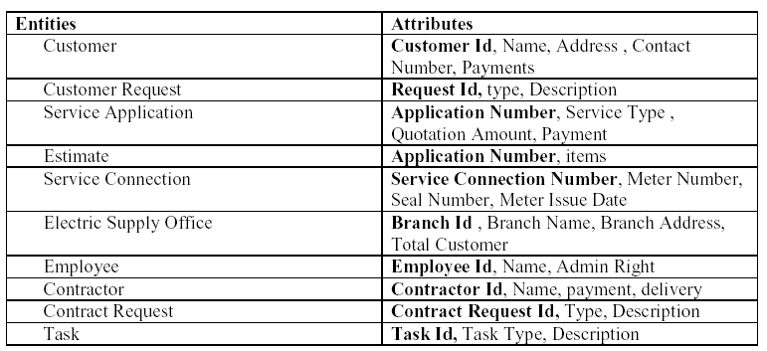

**Relationship between Entities:**

Electric Supply office has Customers1 : N

Electric Supply office has Contractors1 : N

Electric Supply office has Employees1 : N

Customer does Requests 1 : N

Electric Supply serves Requests 1 : N

User uses Service Connection 1 : N

Employees provides Estimates M : N

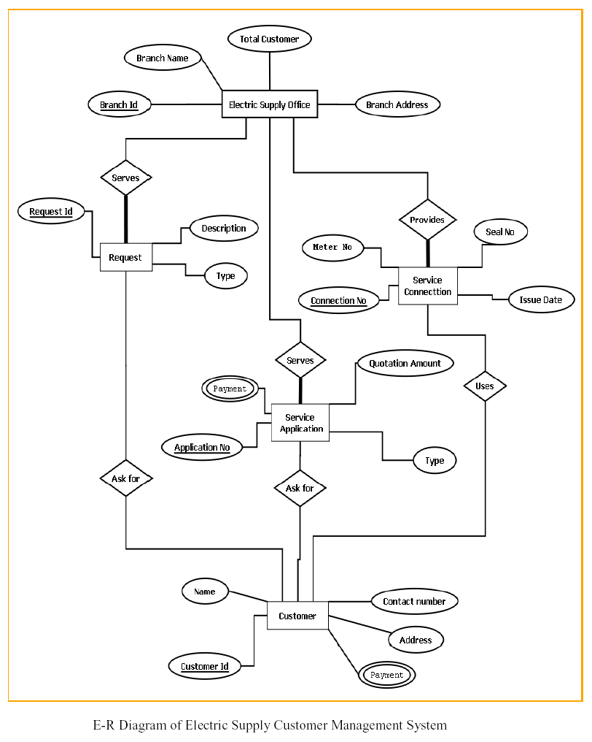

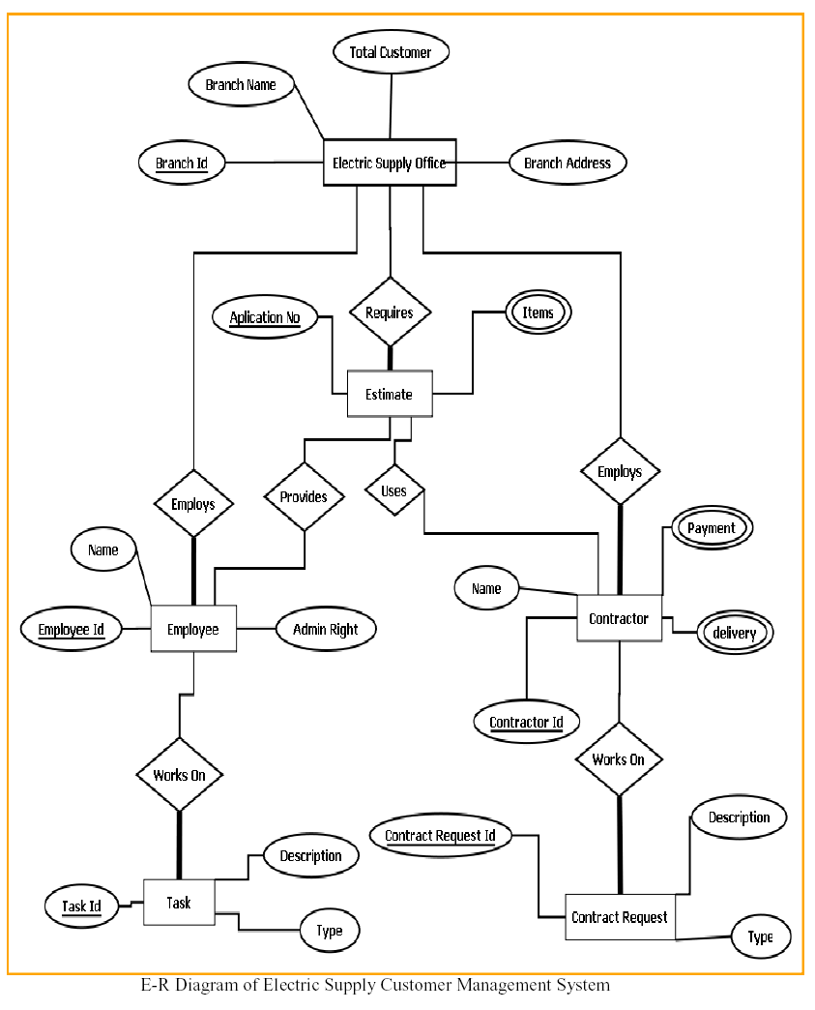

### Context Diagram

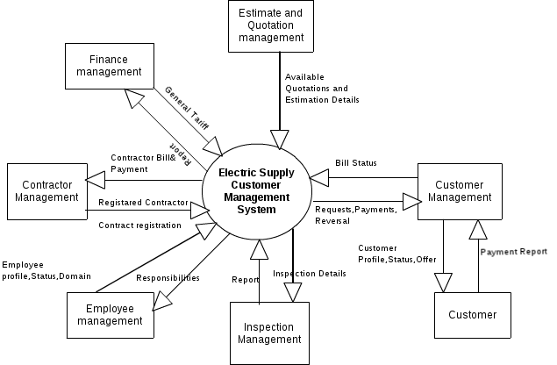

### Data Flow Diagram

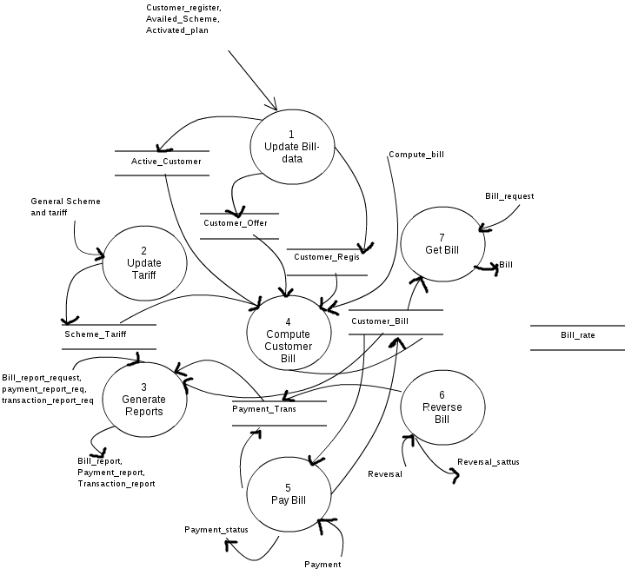

# REFERENCES

* <http://en.wikipedia.org>
* <http://msdn.microsoft.com/en-us/>
* <http://www.microsoft.com/en-us/default.aspx>
* <http://www.codeplex.com/>
* <http://stackoverflow.com/>
* <http://www.codeguru.com/>
* [http://www.w3schools.com](http://www.w3schools.com/)
* [www.mysql.org](http://www.mysql.org)
* Electric Supply Professionals
* **Programming C#** - E. R. Balaguruswamy